**CS 457/557 -- Winter Quarter 2018**

**Project #3**

**Displacement Mapping, Bump Mapping, and Lighting**

Stewart Rodger

rodgers@oregonstate.edu

02/07/2018

The model transformations needed for the displacement mapping are covered in the vertex shader. Using a sine wave that increases as y decreases (with the top, y=1, having no distortion).



Once the z value is calculated, 2 tangent lines and their cross product need to be calculated to get the normal for the fragment shader and the bump mapping.

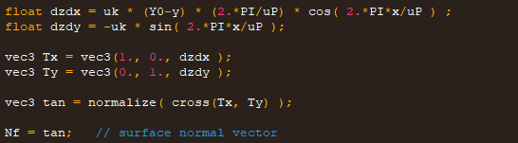

Within the fragment shader, 2 angles need to be calculated with a noise value, and the normal from the vertex shader needs to be rotated.

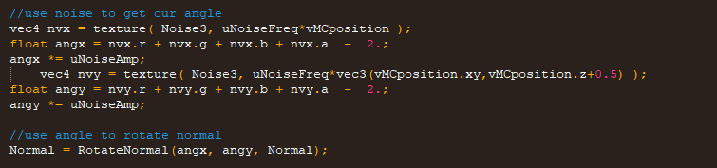

The result is the ability to change the period and frequency of the sin wave (color changed from the default gold to blue using uColor):

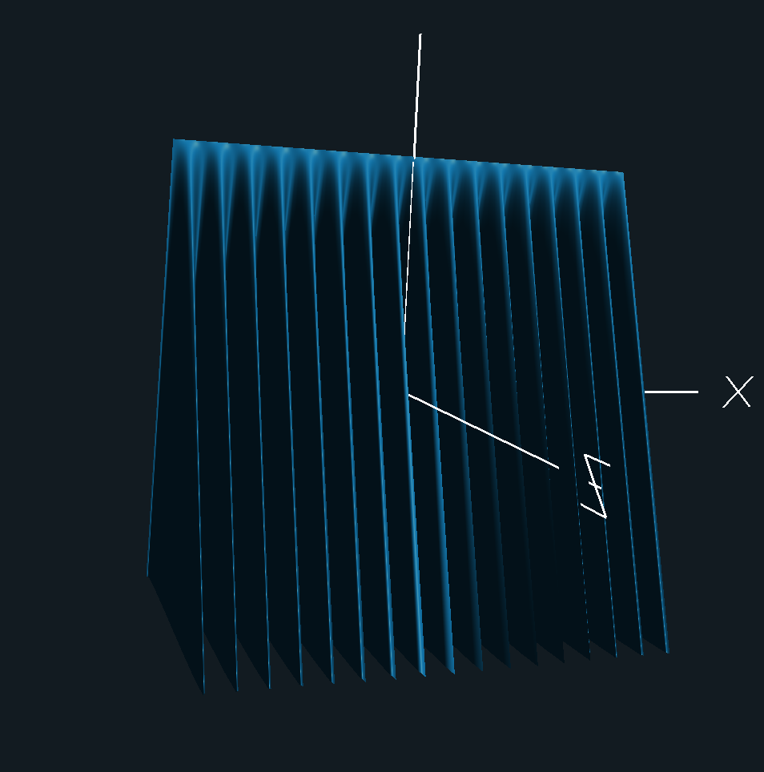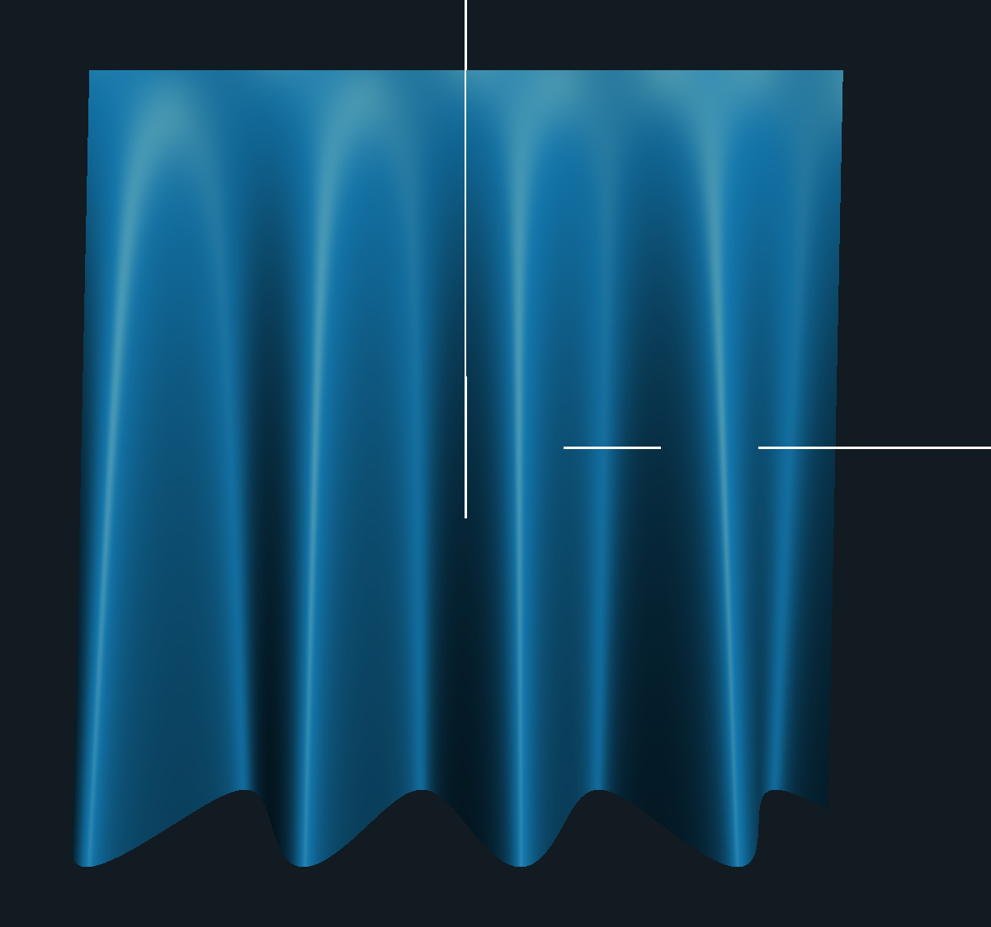

And the amplitude and frequency of the bump mapping:

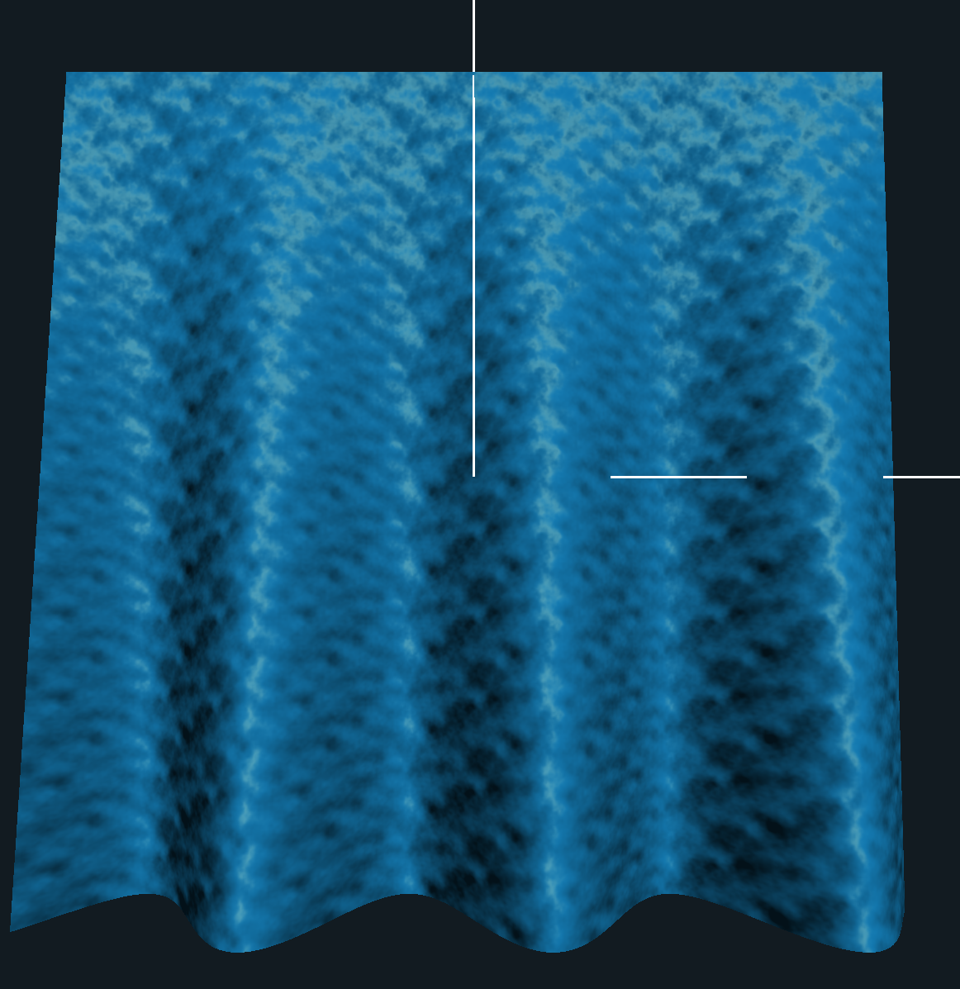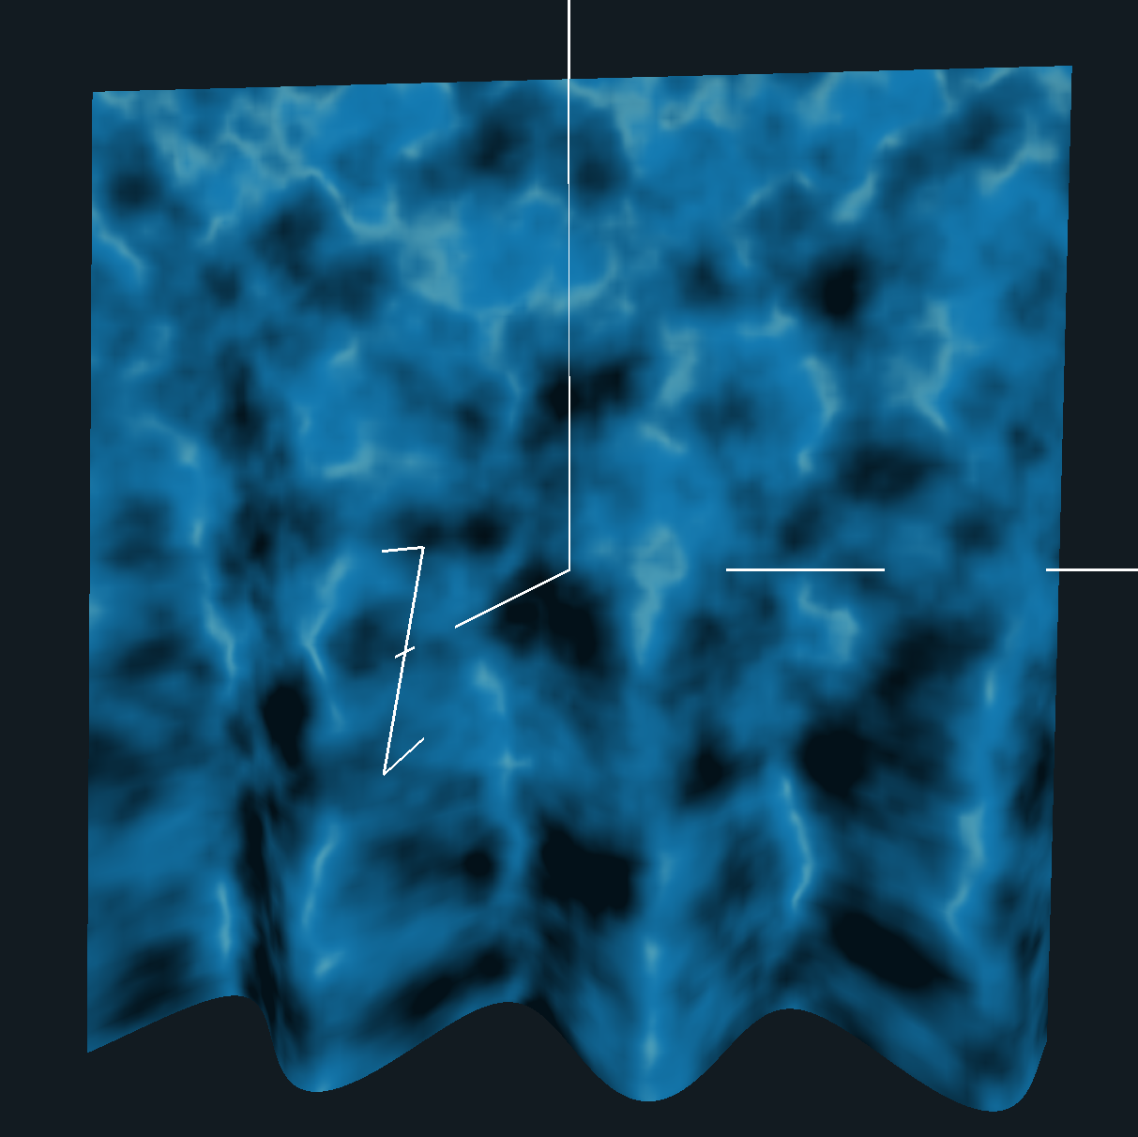

The full video demonstration can be found here:

<https://media.oregonstate.edu/media/t/0_2vwggw2w>